**Course: Advance Bio Informatics**

**Module Title: Synonym Replacement**

**Module No: 98**

**Synonym Replacement**

A boy is playing football. A lad is participating in soccer.

**WordNet**

* Large lexical database of English.
* Nouns, verbs, adjectives & adverbs are grouped into sets of cognitive synonyms (synsets), each expressing distinct concept.
* Synsets are interlinked by means of conceptual-semantic and lexical relations.
* The resulting network of meaningfully related words and concepts can be navigated with the browser.
* Freely and publicly available.
* Useful tool for CL and NLP works.
* WordNet similarity to thesaurus (words and meanings).
* WordNet interlinks not just word forms—strings of letters-but specific senses of words.
* Hierarchical organization is important
* Hierarchies familiar as taxonomies, e.g. in natural sciences
* Daughters are “types of” & share certain properties, inherited from the mother

**WordNet**

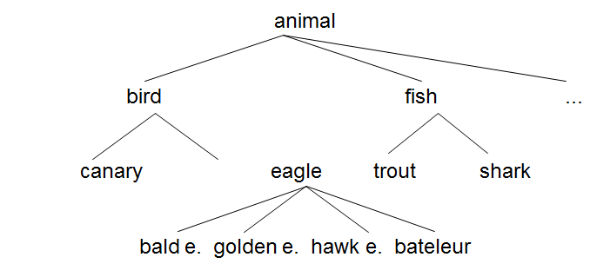

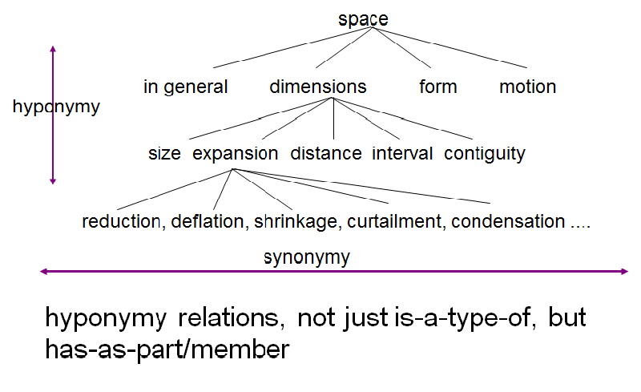

A boy/lad/guy/child is playing football/soccer